**BigBlueButton In Moodle**

**Agenda**

1. **BigBlueButton**
2. **Creating Activity in BigBlueButton**

* **BigBlueButton virtual class**

1. **Creating the Role**

* **User, Moderator and Manager**

1. **Sharing and Presenting**

* **Video conferencing, Presenting PPT and Screen sharing**

1. **White Board**

* **Using the screen as white board**

1. **Polling**

* **Get an instant feedback**

1. **Sharing notes**

* **Export the class contents**

1. **BigBlueButton**

BigBlueButton is an open source web conferencing system. BigBlueButton supports real-time sharing of audio, video, slides (with whiteboard controls), chat, and the screen. Instructors can engage remote students with polling, emojis, multi-user whiteboard, and breakout rooms.

Presenters can record and playback content for later sharing with others.

BigBlueButton is designed for online learning (though it can be used for many other applications). The educational use cases for BigBlueButton are

* Online tutoring (one-to-one)
* Flipped classrooms (recording content ahead of your session)
* Group collaboration (many-to-many)
* Online classes (one-to-many)

1. **Creating Activity in BigBlueButton**

Step 1 : Goto your course

Step 2: Turn editing on

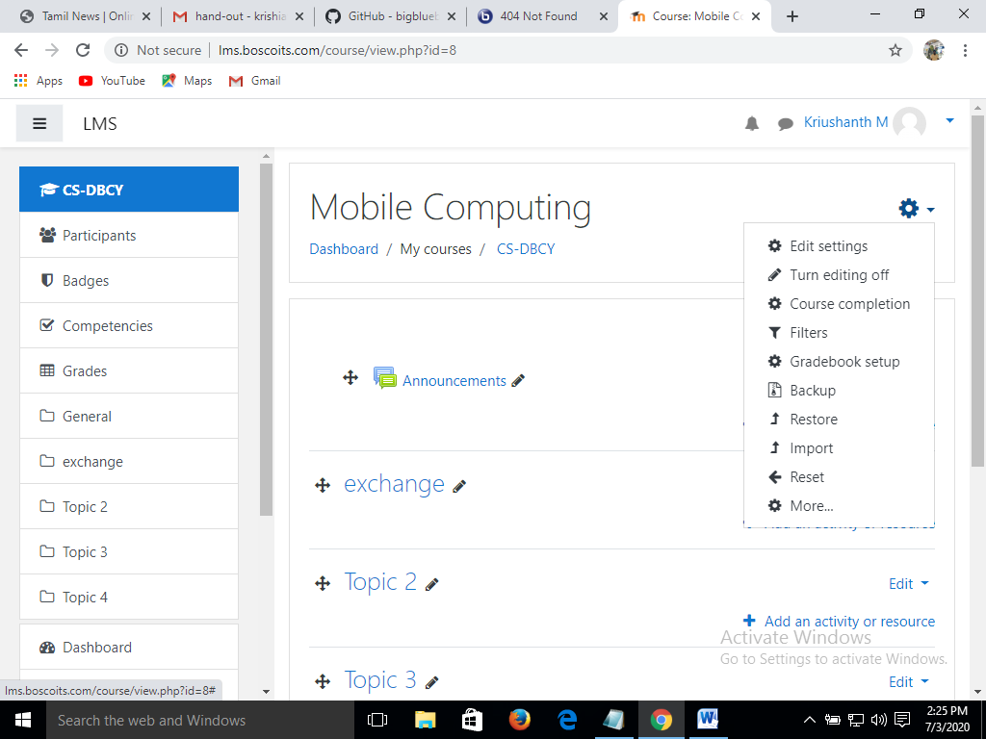

Step 3: Select > Add an activity or resources

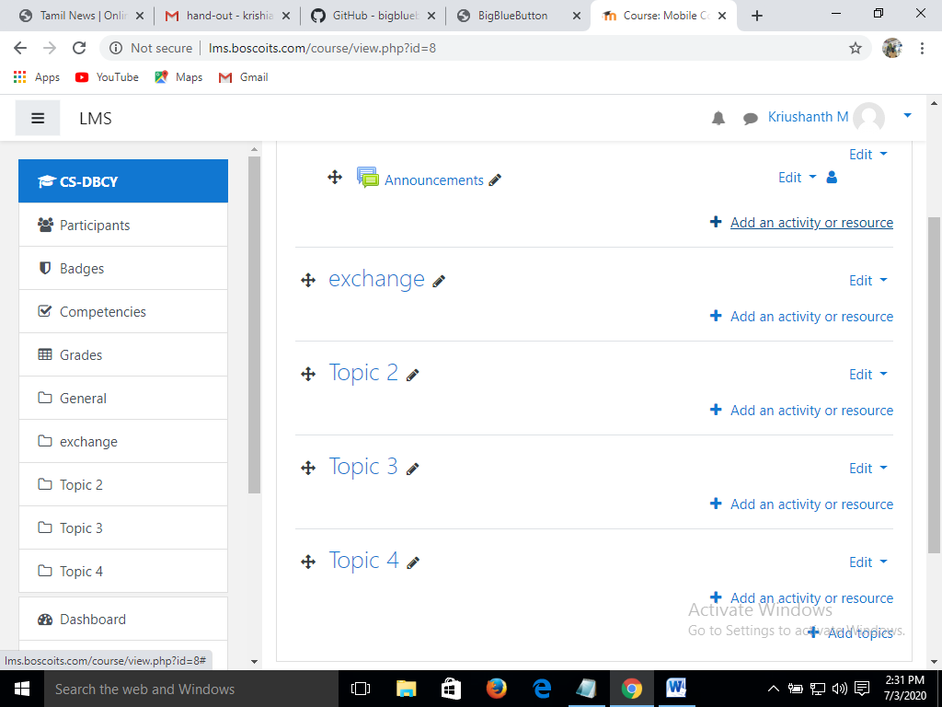

Step 4: Select > BigBlueButton > Click add

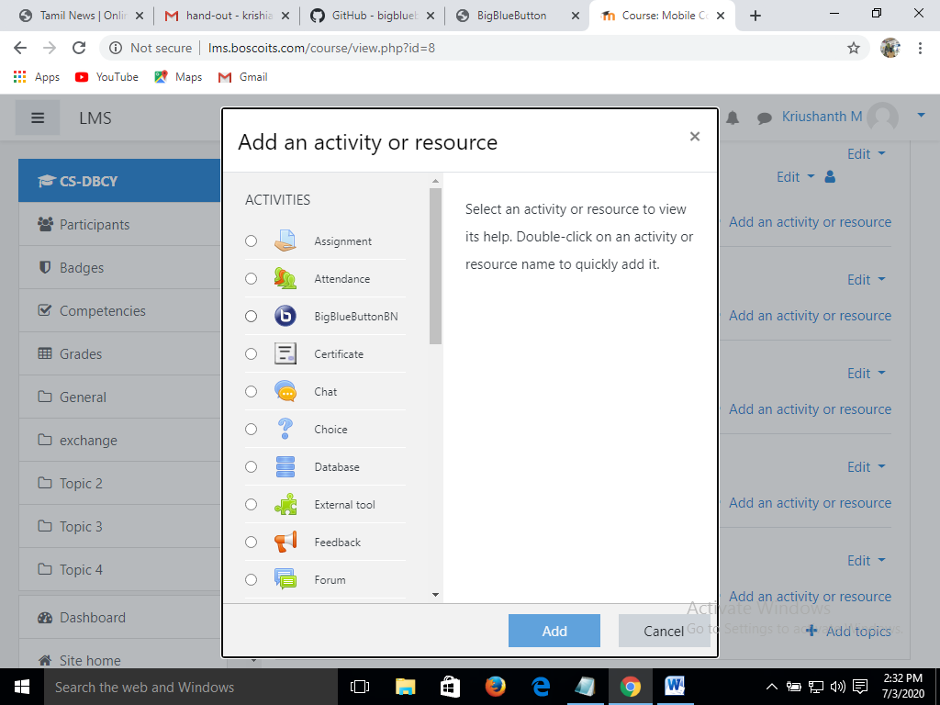

Step 5: In General settings Select any one option as given below

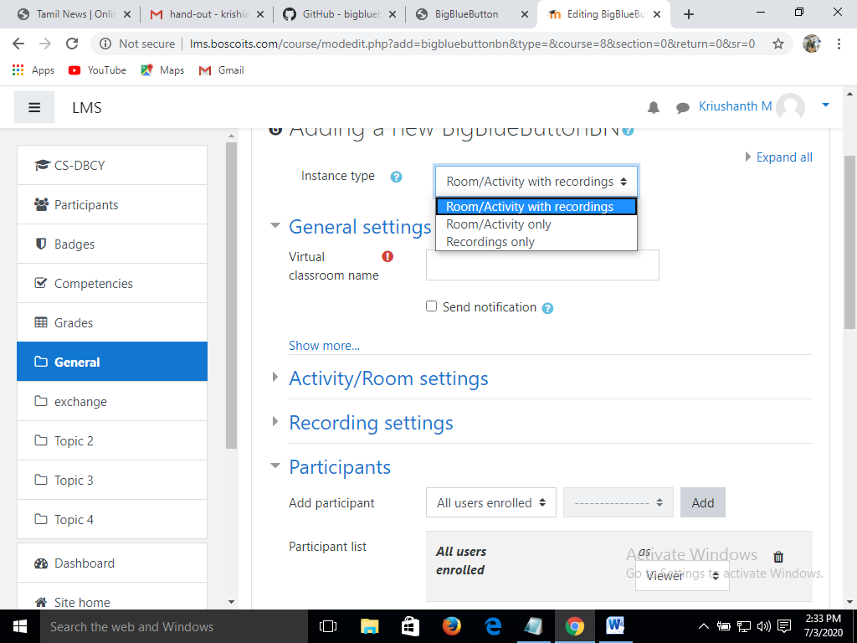

Step 6: Give name for your virtual class

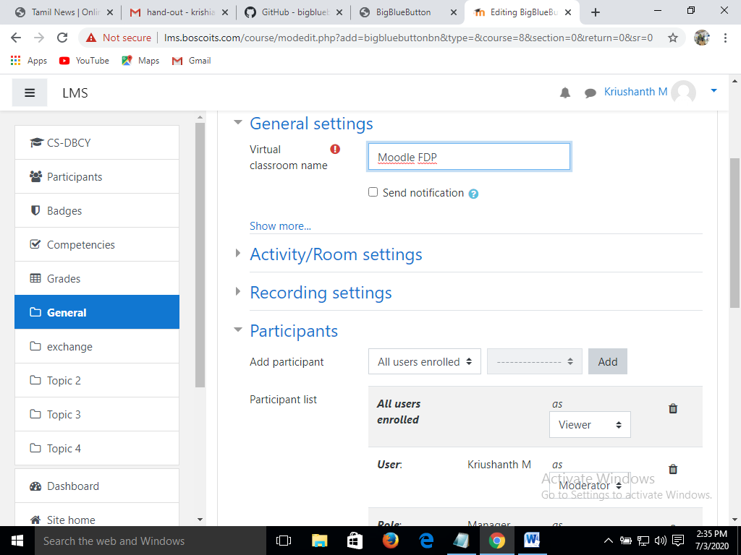

Step 7: Click show more to give the course description

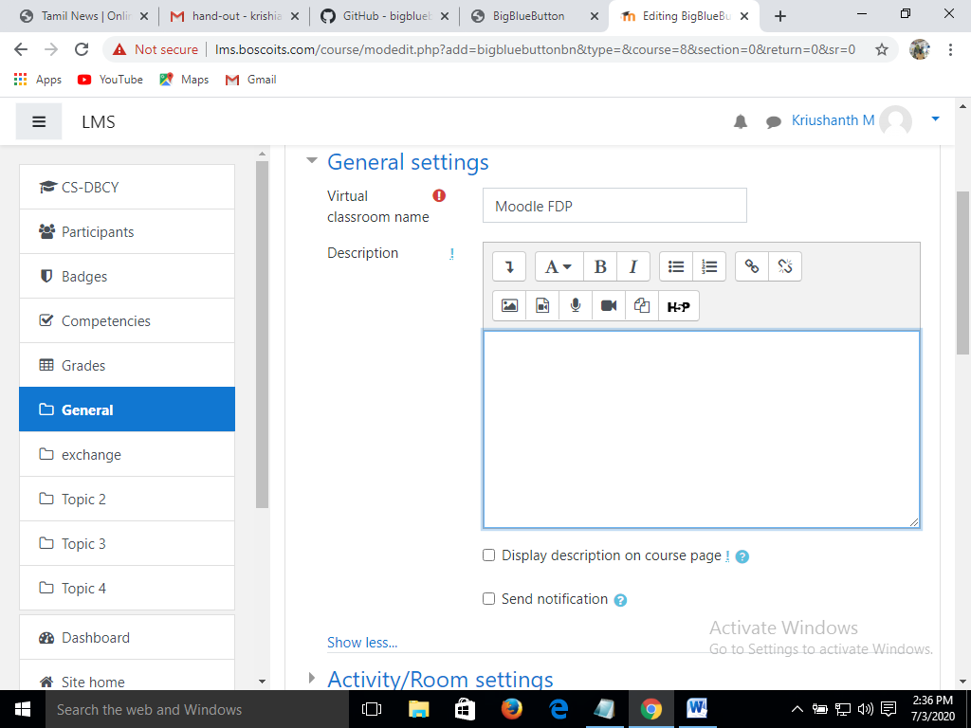

Step 8: In Activity/Room Settings > Give welcome message and you can set the recording and moderator settings

Step 9: Recording settings can be done by the Admin, so leave the settings as it is.

1. **Creating Role**

Step 1: Select the participants based on the role

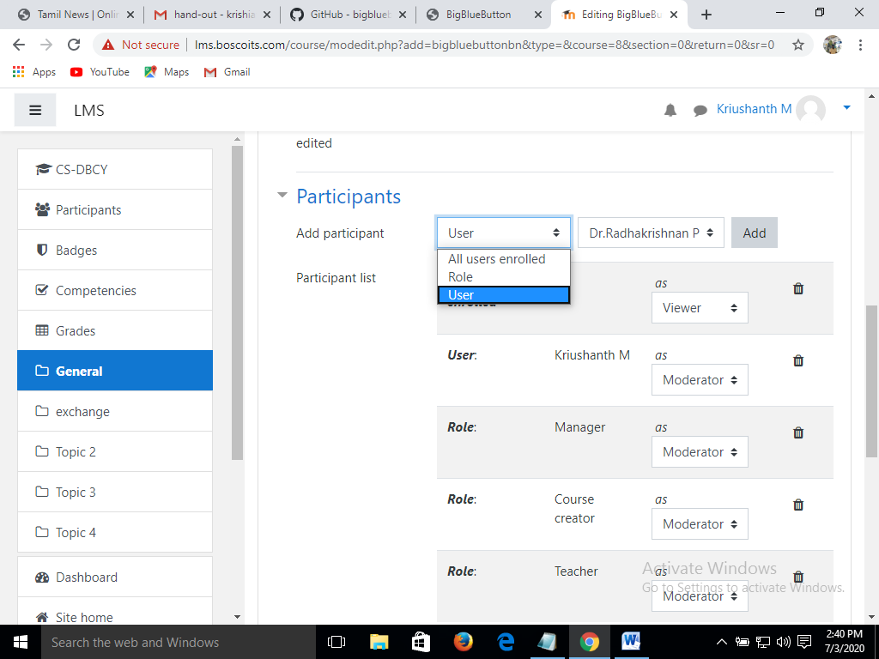

Step 2: Select the participants and add

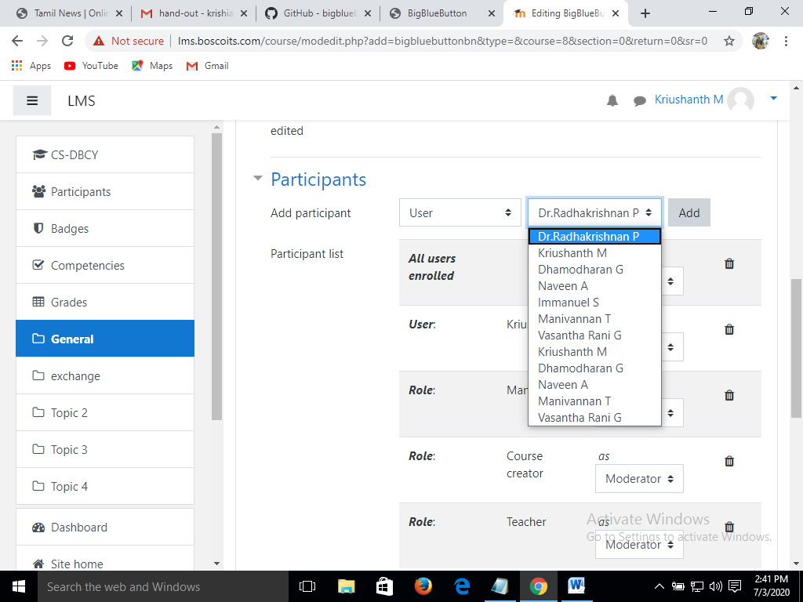

Step 4: Schedule the session when to open and close

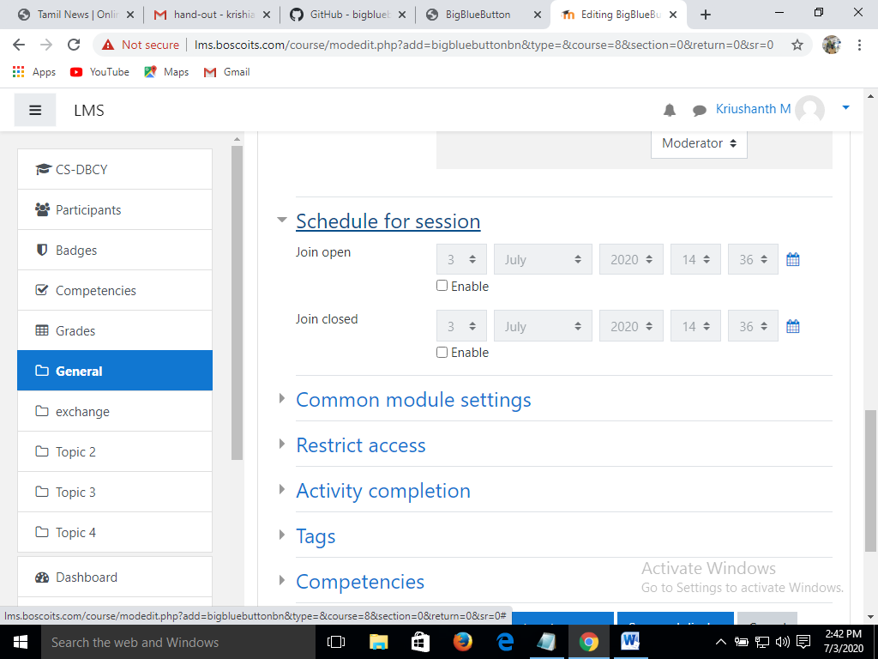

Step 5: Select common module settings as per the moderator’s wish

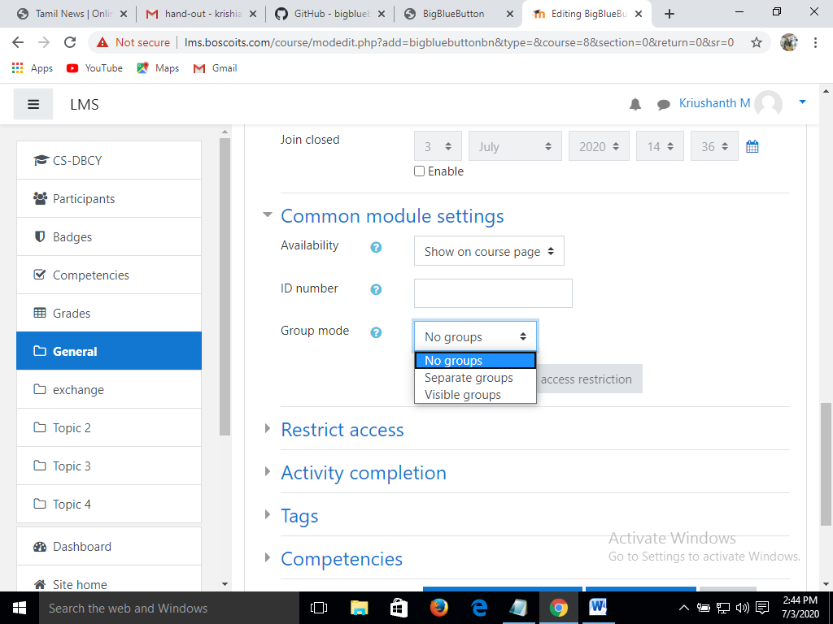

Step 6: Add restrictions

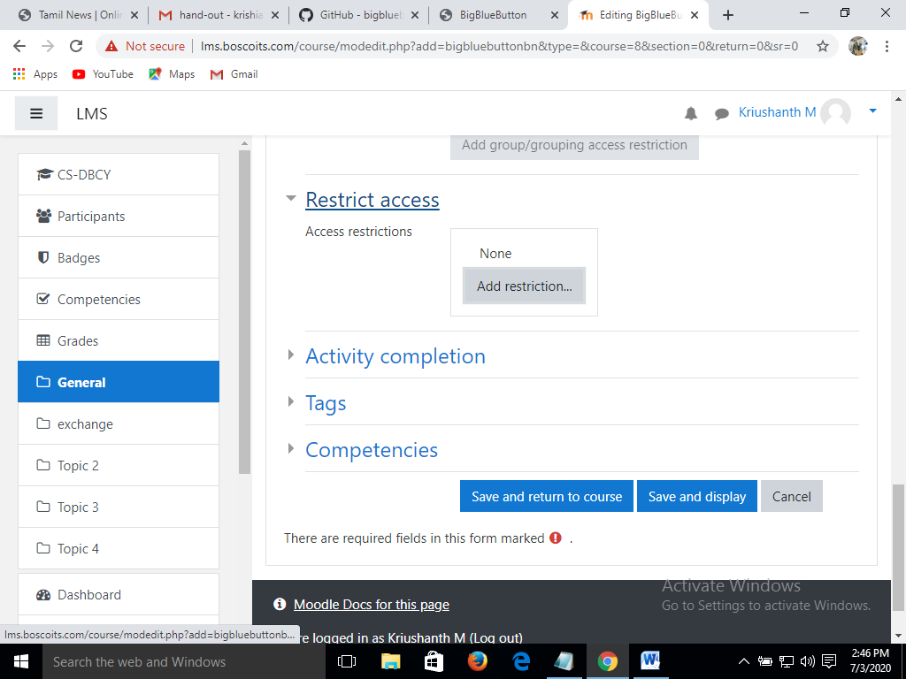

Step 7: Set Activity completion

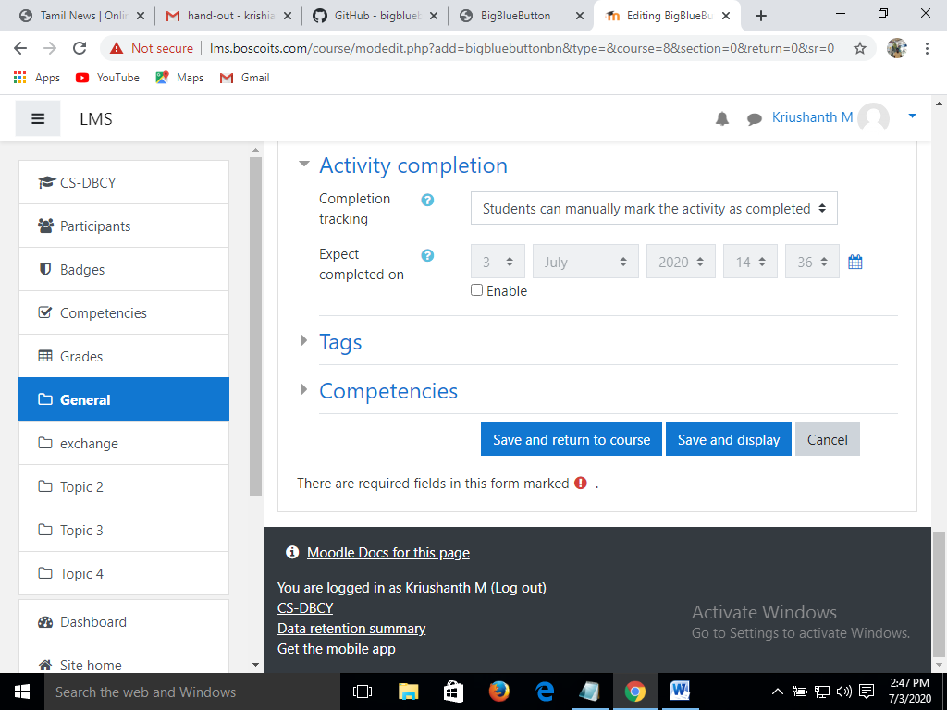

Step 8: If you have Tags and Competencies give, else leave as it is.

Step 9: Save and Display

1. **Sharing and Presenting**

Step 1: To enter into a virtual class room > click on Join session



Step 2: Select your system audio

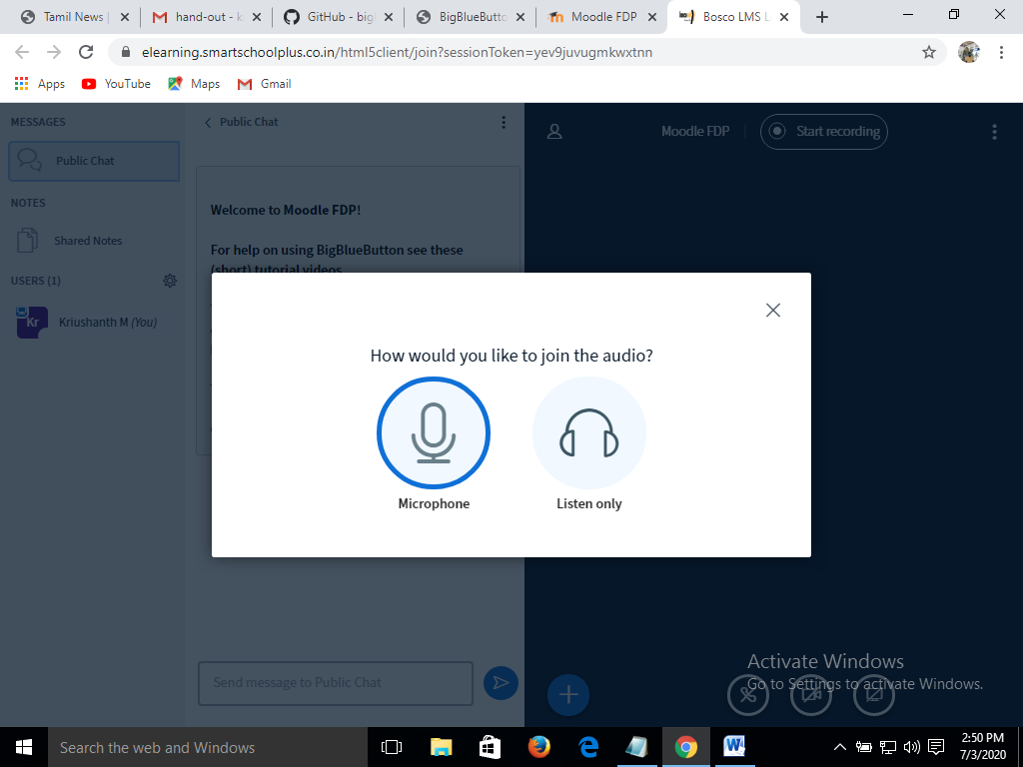

Step 3: Now you have joined to the Virtual class room

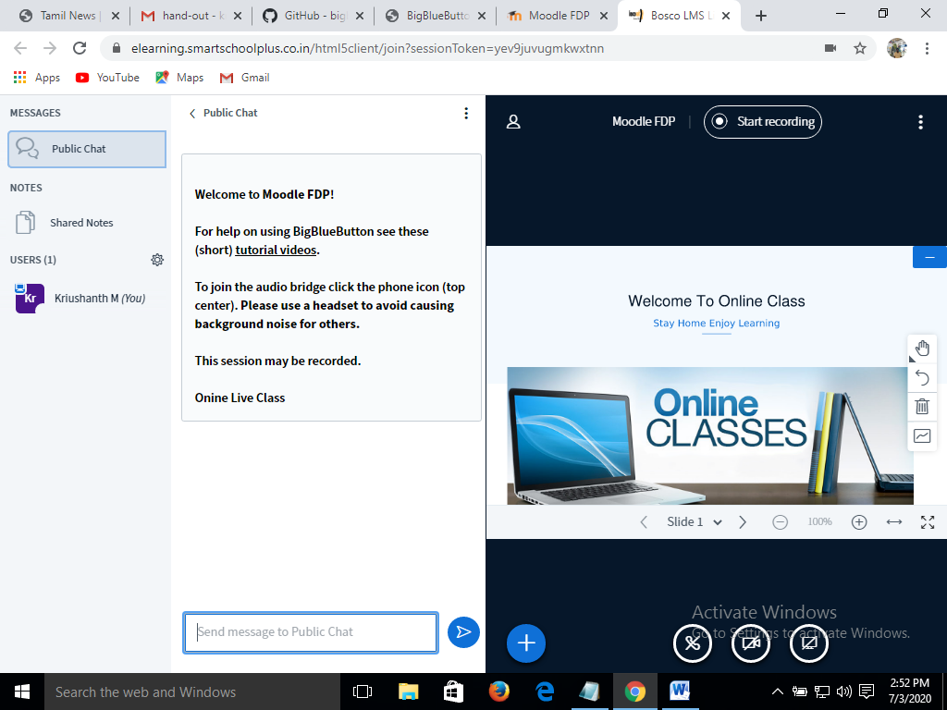

Step 4: Now you can present yourself with audio and video

Step 5: If you want to share your screen > select the screen sharing option next to the camera icon

Step 6: We can have three activities > Polling, Presentation and Sharing external video.

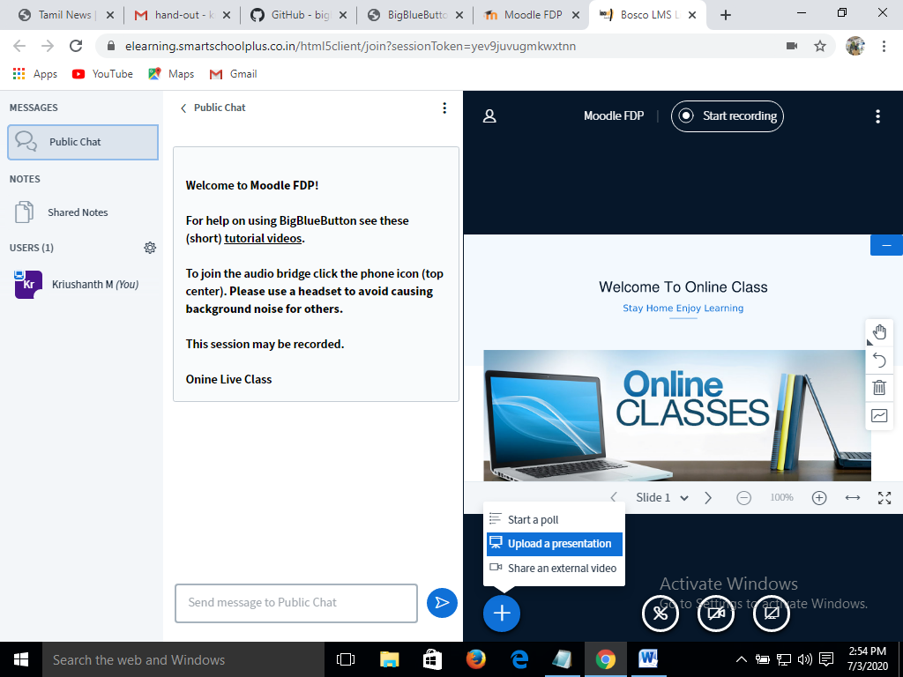

Step 7: For more settings select and settings and have a look

1. **White Board**

Step 1: The screen which your working can be used as a white board

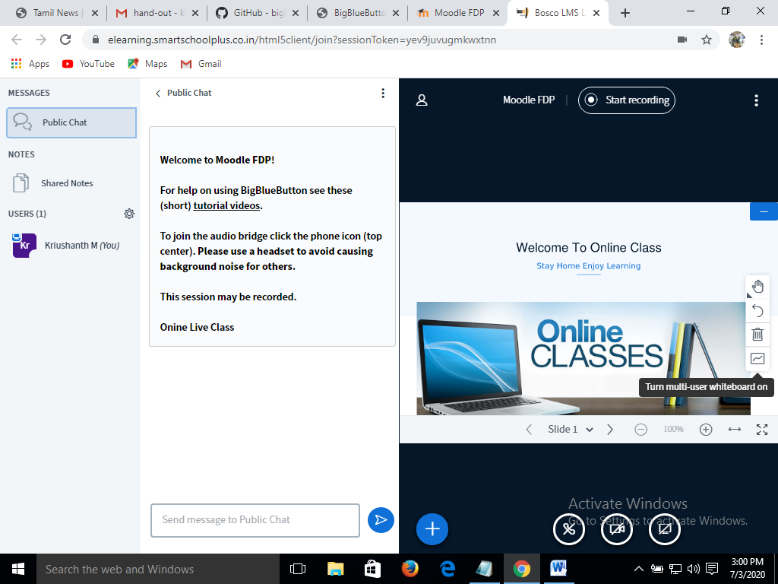

1. **Polling**

Step 1: Select polling to get the instant feedback from the users

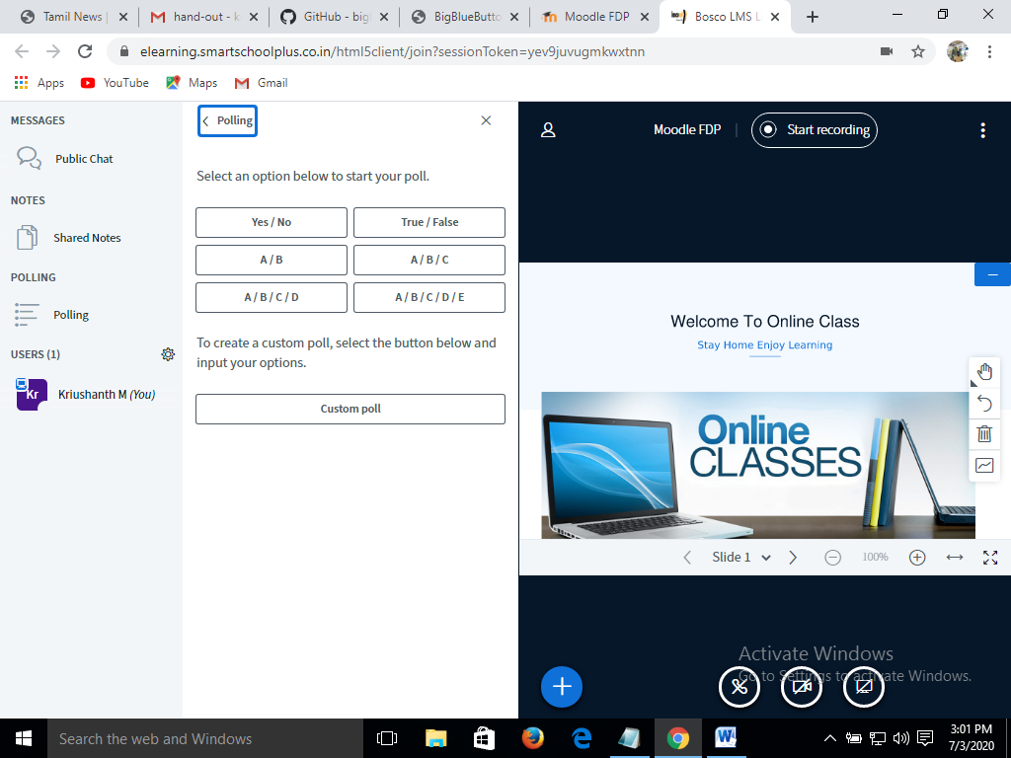

1. **Sharing notes**

Step 1: The common sharing can be exported to HTML, Txt, Word or PDF files.

